제어지능SW개발

11주차 과제

201708015

A

이한결

과제 1.

import numpy as np

import cv2 as cv

img_org = cv.imread("image1.jpg")

img = np.copy(img_org)

x_down, y_down, x_up, y_up = np.zeros(4, dtype=np.uint8)

def Click(event, x, y, flags, param):

global x_down, y_down, x_up, y_up

if event == 2:

if x_down > x_up:

x_down, x_up = x_up, x_down

if y_down > y_up:

y_down, y_up = y_up, y_down

img_event = np.copy(img_org[y_down:y_up+1, x_down:x_up+1])

x_len, y_len = x_up - x_down + 1, y_up - y_down + 1

x_hlen, y_hlen = x_len // 2, y_len // 2

y_left = y - y_hlen

y_right = y + y_hlen + y_len % 2

x_left = x - x_hlen

x_right = x + x_hlen + x_len % 2

y_ld, y_rd, x_ld, x_rd = np.zeros(4, dtype=np.int8)

if y_left < 0:

y_ld = -y_left

y_left = 0

if x_left < 0:

x_ld = -x_left

x_left = 0

if x_right > 255:

x_rd = x_right - 255

x_right = 255

if y_right > 255:

y_rd = y_right - 255

y_right = 255

img[y_left : y_right , x_left : x_right] = img_event[y_ld:y_len-y_rd,x_ld:x_len-x_rd]

cv.imshow("img", img)

if event == 1:

x_down, y_down = x, y

img_org[:,:] = img[:,:]

cv.setMouseCallback("img", Drag)

def Mouse_up(x, y):

global x_up, y_up

x_up = x

y_up = y

cv.imshow('img', img_org)

cv.setMouseCallback("img", Click)

def Drag(event, x, y, flags, param):

global x_down, y_down

xx = x_down

yy = y_down

if event == 0:

img = np.copy(img_org)

cv.rectangle(img, (xx, yy), (x, y), (0, 255, 255))

cv.imshow('img', img)

if event == 4:

Mouse_up(x, y)

def Mouse_down(event, x, y, flags, param):

global x_down, y_down

if event == 1:

x_down, y_down = x, y

cv.setMouseCallback("img", Drag)

cv.namedWindow("img")

cv.setMouseCallback("img", Mouse_down)

cv.imshow("img",img_org)

cv.waitKey(0)

cv.destroyAllWindows()

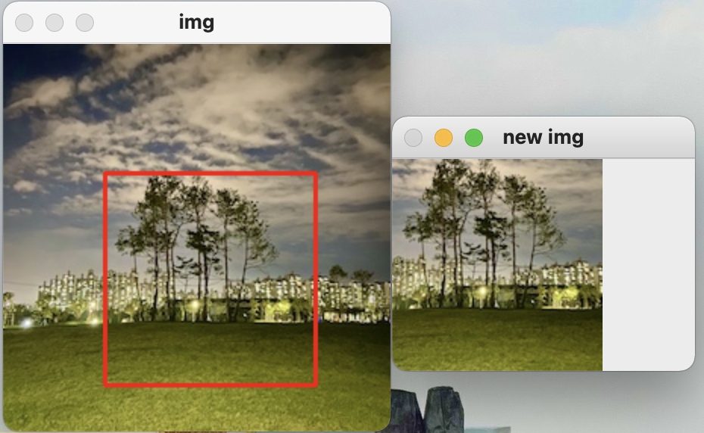과제 2.

import cv2 as cv

import numpy as np

import time

isDragging = False

x0, y0, w, h = -1, -1, -1, -1

blue, red = (255, 0, 0), (0, 0, 255)

turn = 0

img = cv.imread('image2.jpg')

def onMouse(event, x, y, flags, param):

global isDragging, x0, y0, img, turn, roi, w, h

if event == cv.EVENT_LBUTTONDOWN:

isDragging = True

x0, y0 = x, y

elif event == cv.EVENT_MOUSEMOVE:

if isDragging:

img_draw = img.copy()

cv.rectangle(img_draw, (x0,y0),(x,y),blue,2)

cv.imshow('img', img_draw)

elif event == cv.EVENT_LBUTTONUP:

if isDragging:

isDragging = False

w = x-x0

h = y-y0

if w>0 and h>0:

img_draw = img.copy()

cv.rectangle(img_draw, (x0,y0),(x, y), red, 2)

cv.imshow('img', img_draw)

roi = img[y0:y0+h, x0:x0+w]

cv.imwrite("new img.jpg", roi)

cv.imshow("new img",roi)

else:

cv.imshow('img',img)

print('왼쪽부터 드래그를 하세요')

cv.imshow('img',img)

cv.setMouseCallback('img', onMouse)

cv.waitKey()

cv.destroyAllWindows()

과제 3.

import cv2 as cv

import numpy as np

import time

def myShow(title, img):

cv.imshow(title, img)

if cv.waitKey(0) & 0XFF == 27:

cv.destroyAllwindows()

exit(0)

else:

cv.destroyWindow(title)

img = cv.imread('image1.jpg')

cv.imshow("meet",img)

row, cols, ch = img.shape

M = cv.getRotationMatrix2D(((cols-1)/2.0, (row-1)/2.0), 45, 1)

rotationImg = cv.warpAffine(img, M, (cols, row))

myShow("rotation", rotationImg)

pts1 = np.float32([[0,0], [0,255], [255,0]])

pts2 = np.float32([[100,100], [0,255],[255,0]])

M = cv.getAffineTransform(pts1, pts2)

affineImg = cv.warpAffine(img, M, (cols, row))

myShow("affine", affineImg)

pts1 = np.float32([[0,0], [0,255], [255,0], [255,255]])

pts2 = np.float32([[0,0], [0,255], [255,0], [255,255]])

M = cv.getPerspectiveTransform(pts1, pts2)

perspctiveImg = cv.warpPerspective(img, M, (500,500))

cv.rectangle(perspctiveImg, (0,0), (254,254), (0,128,64), 2)

myShow("perspective", perspctiveImg)

cv.destroyAllWindows()

과제 4.

import numpy as np

import cv2 as cv

sample1 = cv.resize(cv.imread("image1.jpg"),(256,256))

image1 = cv.resize(cv.imread("image2.jpg"),(256,256))

image2 = cv.resize(cv.imread("image4.jpg"),(256,256))

cv.imshow('sample1', sample1)

cv.imshow('image1', image1)

cv.imshow('image2', image2)

np.random.seed(seed=5)

for i in range(9):

img = np.zeros((256, 256, 3), dtype=np.int8)

rimg = [0, 1, 2]

np.random.shuffle(rimg)

rn = np.random.randint(low=0, high=2, size=3)

img[:,:,rimg[0]] = sample1[:,:,rn[0]]

img[:,:,rimg[1]] = image1[:,:,rn[1]]

img[:,:,rimg[2]] = image2[:,:,rn[2]]

cv.imshow('img{0}'.format(i+1), img)

cv.waitKey(0)

cv.destroyAllWindows()